Ethan Allen Mr. Round Head Bed

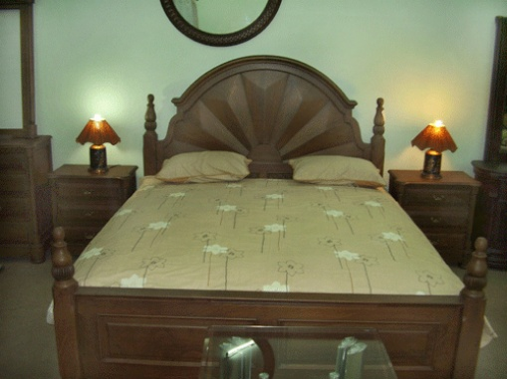

|  |
| --- |
| **DESCRIPTION** |
| ETHAN ALLEN introduces a bed with slim spring mattress design. This set of bed is sure to create the perfect look in any home. The rich wood with sleek mattress helps to take less space perfect for small rooms. Your guests will love this comfortable mood lifting bed and the feeling of refreshment will make you worth sleeping for. |

|  |  |  |
| --- | --- | --- |
| **Price** | **1200$** | |
| **Dimensions** | **H** x **W** x **L** | **22in x 52in x 75in** |
| **Features** | **Slim and low beds will help you to relax and lows your high blood pressure makes circulation good and makes it easy to for you to get up early in the morning.** | |
| **Finished** | **Smooth slim cushion** | |
| **Available in** | **Brown and Red** | |